Spyros Koliavasilis: World Music Artist: Spyros Koliavasilis is an internationally respected vocalist, multi-instrumentalist, and educator whose work bridges Greek, Mediterranean, and global musical traditions. Born in Attiki, Greece, and now based in the United States, Spyros brings more than two decades of deep study, performance, and research into modal music systems, oral traditions, and cross-cultural expression.
In 2025, Spyros was awarded the Maryland Heritage Award, the state’s highest honor recognizing artists who have made outstanding contributions to traditional arts and cultural heritage. This prestigious recognition places him among a select group of master artists whose work sustains and advances living traditions.
While rooted in Greek and Asia Minor musical lineages, Spyros’s artistry extends far beyond national boundaries. His work is firmly situated within the world music ecosystem, engaging audiences through improvisation, historical depth, and contemporary interpretation across cultures.
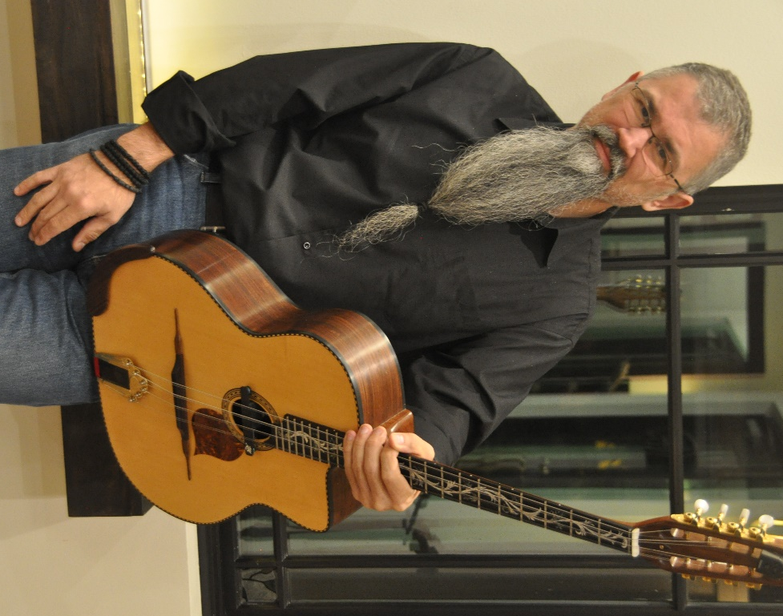
Artistry & Expertise: Spyros plays more than 18 instruments, while his instruments of choice for performances are the oud, Cappadocian lyra (kemane), bouzouki, laouto-guitar, and other fretless guitars. He is a master practitioner of Makam theory and modular/modal systems, bringing nuance and sophistication to improvisation practices such as taksimi.
His artistic foundation lies in the music of Asia Minor (Mikrasia)—including Rebetiko and Smyrneika traditions—yet his work consistently moves outward into broader Mediterranean, and global contexts. Spyros is deeply committed to historical research, archival listening, and the preservation of endangered repertoires, while simultaneously re-imagining them through original arrangements and contemporary collaborations.
This balance of scholarship and creativity defines his sound: grounded, exploratory, and profoundly human.
Bands and Projects: Spyros leads and collaborates on a wide range of ensemble projects, each tailored to different musical contexts and audiences, including:
- Trela – Mediterranean-infused world folk and jazz
- DC Café Aman – Asia Minor, Eastern Mediterranean, Rebetiko repertoire
- Karpouzi Trio – Traditional Greek and Mediterranean music
- Melos – A refined approach to Rebetiko and Smyrneika
- Mortes – Traditional Greek Music
Across these projects, Spyros is known for his musical sensitivity, adaptability, and collaborative spirit, making him equally at home in concert halls, festivals, museums, academic settings, and intercultural performance spaces.
Select Performance: Spyros has appeared at numerous high-profile venues and cultural institutions, including: Strathmore Music Center; Smithsonian Institution; Library of Congress; Maryland Folk Festival; Greek Archdiocese of North America; Embassies, universities, museums, and cultural centers throughout the U.S. His performances are frequently praised for their emotional depth, historical awareness, and ability to engage both specialist and general audiences.
Teaching, Mentorship, and Instruments Design: For over 20 years, Spyros has been a dedicated educator, teaching traditional Greek and world music, Makam/modal systems, improvisation, and more than 20 instruments to students of all ages and backgrounds. His teaching emphasizes listening, embodied learning, and cultural context, making complex musical systems accessible without oversimplification.
In addition to teaching and performing, Spyros is an accomplished luthier, restoring, modifying, and customizing traditional and modern instruments to meet the specific needs of musicians. His work reflects a rare combination of musical insight and technical craftsmanship.
Media & Contact
🎧 Music & Updates:
www.spyroskoliavasilismusic.com
📱 Social Media:
Instagram & Facebook & YouTube: SpyrosKoliavasilisMusic
📩 Bookings, collaborations, interviews & media inquiries:
SpyrosKoliavasilisMusic@gmail.com
Listen to Spyros: here
Listen: Rebetiko
Listen: jazz improve on oud
Listen: DC Café Aman

